# https://upload.wikimedia.org/wikipedia/en/f/f1/Capital_University%2C_Jharkhand_logo.png

# CAPITAL UNIVERSITY - KODERMA

ANALOG ELECTRONIC CIRCUIT - 2 ASSIGNMENT

Name : Arshad Nazir

Electrical and Electronics Engineering

Signature:

Date :

State the role of different sub-circuits of a DC regulated power supply

1.Passive Voltage Regulation. A passive voltage regulator may be used if the power supply consistently produces a voltage greater than what the components on the circuit require. ...

1. Active Voltage Regulation. ...
2. Mains Regulation. ...
3. AC Voltage Stabilization. ...
4. DC Voltage Stabilization.

2. Explain the need for SMPS & UPS.

Switch mode power supplies, SMPS provide **improved efficiency & space saving over traditional linear supplies**, but care has to be taken to ensure noise on the output is low. Switch mode power supplies are widely used because of the advantages they offer in terms of size, weight, cost, efficiency and overall performance. It is used in **the railway system, security system**. It is also used in mobile and also as lighting.

An Uninterruptible Power Supply (UPS) **provides battery backup power when the flow of electricity drops to an inadequate voltage**, or if it stops. An uninterrupted power source is vital for the mission-critical environment. **Protect against power interruptions**. **Provide adequate power** during short-term interruptions and “ride-through” time to convert to backup supply. Refine the quality of the power as it reaches your building, office and equipment.

3. Explain IC voltage Regulator using LM-317.

The LM317 is an adjustable 3−terminal positive voltage regulator capable of supplying in excess of 1.5 A over an output voltage range of 1.2 V to 37 V. This voltage regulator is exceptionally easy to use and requires only two external resistors to set the output voltage. Further, it employs internal current limiting, thermal shutdown and safe area compensation, making it essentially blow−out proof. The LM317 serves a wide variety of applications including local, on card regulation. This device can also be used to make a programmable output regulator, or by connecting a fixed resistor between the adjustment and output, the LM317 can be used as a precision current regulator.

Features

• Output Current in Excess of 1.5 A

• Output Adjustable between 1.2 V and 37 V

• Internal Thermal Overload Protection

• Internal Short Circuit Current Limiting Constant with Temperature

• Output Transistor Safe−Area Compensation

• Floating Operation for High Voltage Applications

• Eliminates Stocking many Fixed Voltages

• Available in Surface Mount D2PAK−3, and Standard 3−Lead Transistor Package

• NCV Prefix for Automotive and Other Applications Requiring Unique Site and Control Change Requirements; AEC−Q100 Qualified and PPAP Capable

• These Devices are Pb−Free, Halogen Free/BFR Free and are RoHS Compliant

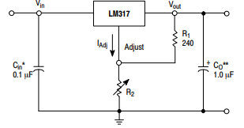

Vout =1.25V(1+R2/R1)+IADJR2

4. Define Regulator & explain the need for voltage regulators in power supplies

voltage regulator, **any electrical or electronic device that maintains the voltage of a power source within acceptable limits**. The voltage regulator is needed to keep voltages within the prescribed range that can be tolerated by the electrical equipment using that voltage.

* Positive and negative voltage regulators can be used together to power sensors, [op-amps](https://www.digikey.com/en/products/detail/sparkfun-electronics/BOB-14874/1568-1950-ND/9697948), and other electronic modules that need both voltages.
* All common microcontroller development boards, like those from Arduino and Raspberry Pi, can be powered using the LM7805 output to the 5 V pin. Arduino boards also have an onboard low-dropout voltage regulator like On Semiconductor’s NCP1117S to regulate power input coming from the barrel jack or Vin.

Voltage regulators are one of the most important components of an electronic circuit. They are responsible for its safe and consistent functioning. Extremely high voltage regulators use power electronics circuits with high power ratings in industrial settings on heavy machinery.

Depending on the design, it may be used **to regulate one or more AC or DC voltages**. Electronic voltage regulators are found in devices such as computer power supplies where they stabilize the DC voltages used by the processor and other elements.

6.Define UPS. With a neat block diagram explain the working principle of online & offline UPS.

In a UPS, the energy is generally stored in flywheels, [batteries](https://www.electrical4u.com/battery-working-principle-of-batteries/), or super [capacitors](https://www.electrical4u.com/what-is-capacitor/). When compared to other immediate power supply system, UPS have the advantage of immediate protection against the input power interruptions.

It has very short on-battery run time; however this time is enough to safely shut down the connected apparatus (computers, telecommunication equipment etc) or to switch on a standby power source.

UPS can be used as a protective device for some hardware which can cause serious damage or loss with a sudden power disruption.

Uninterruptible power source, Battery backup and Flywheel back up are the other names often used for UPS. The available size of UPS units ranges from 200 VA which is used for a solo computer to several large units up to 46 MVA.

**Off-line UPS**

This UPS is also called as Standby UPS system which can give only the most basic features. Here, the primary source is the filtered AC mains (shown in solid path in figure 1).

When the power breakage occurs, the transfer switch will select the backup source (shown in dashed path in figure 1).

Thus we can clearly see that the stand by system will start working only when there is any failure in mains. In this system, the AC voltage is first rectified and stored in the storage battery connected to the rectifier.

When power breakage occurs, this DC voltage is converted to AC voltage by means of a [power inverter](https://www.electrical4u.com/power-inverter/), and is transferred to the load connected to it.

This is the least expensive UPS system and it provides surge protection in addition to back up. The transfer time can be about 25 milliseconds which can be related to the time taken by the UPS system to detect the utility [voltage](https://www.electrical4u.com/voltage-or-electric-potential-difference/) that is lost. The block diagram is shown below.

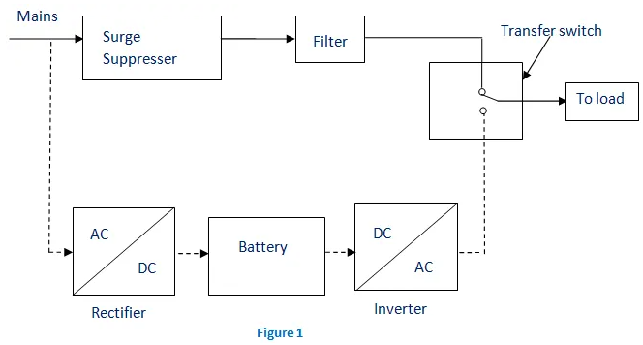

### On-line UPS

In this type of UPS, double conversion method is used. Here, first the AC input is converted into DC by rectifying process for storing it in the rechargeable battery.

This DC is converted into AC by the process of inversion and given to the load or equipment which it is connected (figure 2).

This type of UPS is used where electrical isolation is mandatory. This system is a bit more costly due to the design of constantly running converters and cooling systems.

Here, the rectifier which is powered with the normal AC [current](https://www.electrical4u.com/electric-current-and-theory-of-electricity/) is directly driving the inverter. Hence it is also known as Double conversion UPS. The block diagram is shown below.

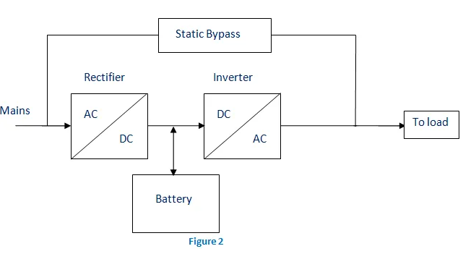

When there is any power failure, the rectifier have no role in the circuit and the steady power stored in the [batteries](https://www.electrical4u.com/battery-working-principle-of-batteries/) which is connected to the inverter is given to the load by means of transfer switch.

Once the power is restored, the rectifier begins to charge the batteries. To prevent the batteries from overheating due to the high power rectifier, the charging current is limited. During a main power breakdown, this UPS system operates with zero transfer time.

The reason is that the backup source acts as a primary source and not the main AC input. But the presence of inrush current and large load step current can result in a transfer time of about 4-6 milliseconds in this system.

6.Define (i)Rectification (ii)Ripple factor (iii) Ripple frequency (iv)PIV (v) Efficiency

Rectification

A rectifier is an electrical device that converts alternating current, which periodically reverses direction, to direct current, which flows in only one direction. The reverse operation is performed by the inverter. The process is known as rectification, since it "straightens" the direction of current.

Ripple Factor.

Ripple factor: Ripple factor is **a measure of effectiveness of a rectifier circuit**. It is defined as the ratio of RMS value of the AC component (ripple component) Irrms in the output waveform to the DC component VDC in the output waveform.

Ripple frequency

It is the frequency of the residual AC voltage after it has been rectified to DC in a power supply. It rides on top of the DC voltage. For a half-wave rectifier, the ripple frequency is the same as the AC frequency, for a full-wave one it is twice the original AC frequency.

Peak inverse Voltage.

The peak inverse voltage is either the specified maximum voltage that a diode rectifier can block, or, alternatively, the maximum voltage that a rectifier needs to block in a given circuit. The peak inverse voltage rises with rise in temperature and decrease with decrease in temperature.

Efficiency.

The efficiency of a system in electronics and electrical engineering is defined as useful power output divided by the total electrical power consumed.

7. Classify Amplifiers

## **Based on number of stages**

Depending upon the number of stages of Amplification, there are Single-stage amplifiers and Multi-stage amplifiers.

**Single-stage Amplifiers** − This has only one transistor circuit, which is a singlestage amplification.

**Multi-stage Amplifiers** − This has multiple transistor circuit, which provides multi-stage amplification.

## **Based on its output**

Depending upon the parameter that is amplified at the output, there are voltage and power amplifiers.

* **Voltage Amplifiers** − The amplifier circuit that increases the voltage level of the input signal, is called as Voltage amplifier.
* **Power Amplifiers** − The amplifier circuit that increases the power level of the input signal, is called as Power amplifier.

## **Based on the input signals**

Depending upon the magnitude of the input signal applied, they can be categorized as Small signal and large signal amplifiers.

* **Small signal Amplifiers** − When the input signal is so weak so as to produce small fluctuations in the collector current compared to its quiescent value, the amplifier is known as Small signal amplifier.
* **Large signal amplifiers** − When the fluctuations in collector current are large i.e. beyond the linear portion of the characteristics, the amplifier is known as large signal amplifier.

## **Based on the frequency range**

Depending upon the frequency range of the signals being used, there are audio and radio amplifiers.

* **Audio Amplifiers** − The amplifier circuit that amplifies the signals that lie in the audio frequency range i.e. from 20Hz to 20 KHz frequency range, is called as audio amplifier.
* **Power Amplifiers** − The amplifier circuit that amplifies the signals that lie in a very high frequency range, is called as Power amplifier.

## **Based on Biasing Conditions**

Depending upon their mode of operation, there are class A, class B and class C amplifiers.

**Class A amplifier** − The biasing conditions in class A power amplifier are such that the collector current flows for the entire AC signal applied.

**Class B amplifier** − The biasing conditions in class B power amplifier are such that the collector current flows for half-cycle of input AC signal applied.

**Class C amplifier** − The biasing conditions in class C power amplifier are such that the collector current flows for less than half cycle of input AC signal applied.

**Class AB amplifier** − The class AB power amplifier is one which is created by combining both class A and class B in order to have all the advantages of both the classes and to minimize the problems they have.

## **Based on the Coupling method**

Depending upon the method of coupling one stage to the other, there are RC coupled, Transformer coupled and direct coupled amplifier.

* **RC Coupled amplifier** − A Multi-stage amplifier circuit that is coupled to the next stage using resistor and capacitor (RC) combination can be called as a RC coupled amplifier.
* **Transformer Coupled amplifier** − A Multi-stage amplifier circuit that is coupled to the next stage, with the help of a transformer, can be called as a Transformer coupled amplifier.
* **Direct Coupled amplifier** − A Multi-stage amplifier circuit that is coupled to the next stage directly, can be called as a direct coupled amplifier.

## **Based on the Transistor Configuration**

Depending upon the type of transistor configuration, there are CE CB and CC amplifiers.

* **CE amplifier** − The amplifier circuit that is formed using a CE configured transistor combination is called as CE amplifier.
* **CB amplifier** − The amplifier circuit that is formed using a CB configured transistor combination is called as CB amplifier.
* **CC amplifier** − The amplifier circuit that is formed using a CC configured transistor combination is called as CC amplifier.

8.Define i) CMRR ii) Gain iii) Gain-bandwidth product iv) Slew rate v) Input impedance for an op-amp

1.the common mode rejection ratio of a differential amplifier is a metric used to quantify the ability of the device to reject common-mode signals, i.e. those that appear simultaneously and in-phase on both inputs.

2.Gain.

Gain is **the ratio of output voltage to input voltage of an amplifier**, where VIN1 and VIN2 are two inputs, subtracted. In a real circuit, the gain will be frequency dependent, but let us start with consideration of the gain in an ideal amplifier.

3.Gain bandwidth product.

The gain–bandwidth product for an amplifier is the product of the amplifier's bandwidth and the gain at which the bandwidth is measured.

4.slew rate.

slew rate is defined as the change of voltage or current, or any other electrical quantity, per unit of time. Expressed in SI units, the unit of measurement is volts/second or amperes/second, but is usually expressed in terms of microseconds or nanoseconds.

5.Input impedance for an op-amp

The input impedance of an op amp is **the impedance that is seen by the driving device**. The lower the input impedance of the op amp, the greater is the amount of current that must be supplied by the signal source.

9. Explain the operation of op-amp comparator with waveforms.

An op-amp is a multi-stage , direct coupled, high gain negative feedback amplifier that has one or more differential amplifiers and its concluded with a level translator and an output stage.A voltage-shunt feedback is provided in an op-amp to obtain a stabilized voltage gain. Op-amps are available as [**Integrated Circuits (IC’s)**](https://www.circuitstoday.com/category/integrated-circuits).

The main use of an op-amp is to amplify ac and dc input signals and was initially used for basic mathematical operations such as addition, subtraction, multiplication, differentiation and integration. Nowadays , the application of op-amp’s varies from ac and dc signal amplification to use in active filters, oscillators, comparators, voltage regulators, instrumentation and control systems, pulse generators, square wave generators and many more electronic circuits. For the design of all these circuits the op-amp’s are manufactured with integrated transistors, diodes, capacitors and resistors, thus making it an extremely compact, multi tasking, low cost, highly reliable and temperature stable integrated circuit. It is also designed in such a way that the external characteristics can be changed with the addition of external components like capacitors and resistors. Thus it can act as a complete amplifier with various characteristics.

### Block Diagram Of Operational Amplifier (Op-amp)

The block diagram of a multi-stage operational amplifier is given below.

**[[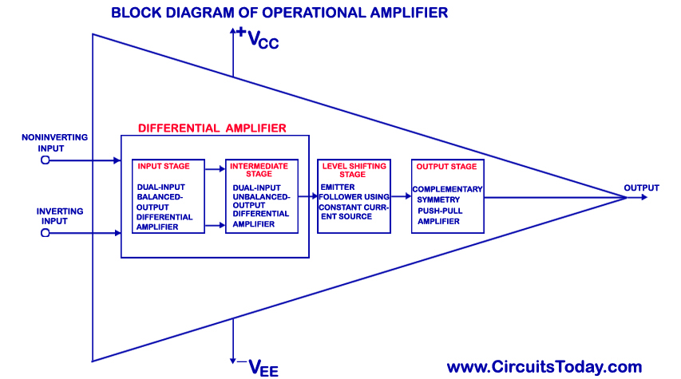](https://www.circuitstoday.com/wp-content/uploads/2009/09/Block-Diagram-of-Operational-Amplifier-Op-Amp.jpg)](https://www.circuitstoday.com/wp-content/uploads/2009/09/Block-Diagram-of-Operational-Amplifier-Op-Amp.jpg)**

Block Diagram of Operational Amplifier (Op-Amp)

The op-amp begins with a differential amplifier stage, which operates in the differential mode. Thus the inputs noted with ‘+’ &  ‘- ‘ . The positive sign is for the non-inverting input and negative is for the inverting input. The non-inverting input is the ac signal (or dc) applied to the differential amplifier which produces the same polarity of the signal at the output of  op-amp. The inverting signal input is the ac signal (or dc) applied to the differential amplifier. This produces a 180 degrees  out of phase signal at the output.

The inverting and non-inverting inputs are provided to the input stage which is a dual input, balanced output differential amplifier. The voltage gain required for the amplifier is provided in this stage along with the input resistance for the op-amp. The output of the initial stage is given to the intermediate stage, which is driven by the output of the input stage.In this stage direct coupling is used, which makes the dc voltage at the output of the intermediate stage above ground potential. Therefore, the dc level at its output must be shifted down to 0Volts with respect to the ground. For this, the level shifting stage is used where usually an emitter follower with the constant current source is applied. The level shifted signal is then given to the output stage where a push-pull amplifier increases the output voltage swing of the signal and also increases the current supplying capability of the op-amp.

12. List any 5 ideal characteristics of op-amp.

* 1.1 Infinite Input Resistance. ...
* 1.2 Zero Output Impedance. ...
* 1.3 Infinite Open-loop Gain. ...
* 1.4 Infinite Common-mode Rejection Ratio. ...
* 1.5 Infinite Bandwidth.

13. Explain the working of Schmitt trigger circuit using op-amp; and also sketch the hysteresis plot.

14.Demonstrate how op-amp can be used as a differentiator.

15.Explain simple positive clamper clamper circuit.

16. Illustrate the operation of RC differentiator circuit.

17. Explain negative shunt clipper

## **Negative Shunt Clipper**

A Clipper circuit in which the diode is connected in shunt to the input signal and that attenuates the negative portions of the waveform, is termed as Negative Shunt Clipper. The following figure represents the circuit diagram for **negative shunt clipper**.

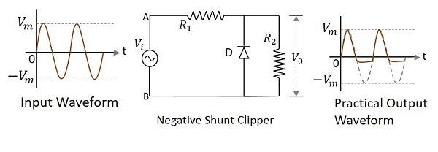

**Positive Cycle of the Input** − When the input voltage is applied, the positive cycle of the input makes the point A in the circuit positive with respect to the point B. This makes the diode reverse biased and hence it behaves like an open switch. Thus the voltage across the load resistor equals the applied input voltage as it completely appears at the output V0V0

**Negative Cycle of the Input** − The negative cycle of the input makes the point A in the circuit negative with respect to the point B. This makes the diode forward biased and hence it conducts like a closed switch. Thus the voltage across the load resistor becomes zero as no current flows through it.

### Waveforms

In the above figures, if the waveforms are observed, we can understand that just a portion of the negative peak was clipped. This is because of the voltage across V0V0. But the ideal output was not meant to be so. Let us have a look at the following figures.

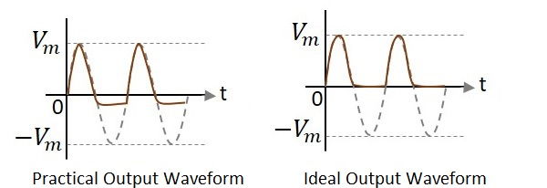

Unlike the ideal output, a bit portion of the negative cycle is present in the practical output due to the diode conduction voltage which is 0.7v. Hence there will be a difference in the practical and ideal output waveforms.

### Negative Shunt Clipper with positive **Vr**Vr

A Clipper circuit in which the diode is connected in shunt to the input signal and biased with positive reference voltage VrVr and that attenuates the negative portions of the waveform, is termed as **Negative Shunt Clipper with positive**VrVr. The following figure represents the circuit diagram for negative shunt clipper when the reference voltage applied is positive.

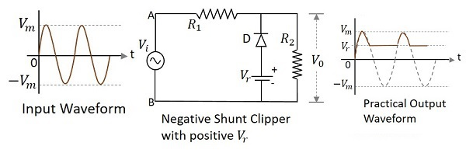

During the positive cycle of the input the diode gets reverse biased and behaves as an open switch. So whole of the input voltage, which is greater than the reference voltage applied, appears at the output. The signal below reference voltage level gets clipped off.

During the negative half cycle, as the diode gets forward biased and the loop gets completed, no output is present.

### Negative Shunt Clipper with negative **Vr**Vr

A Clipper circuit in which the diode is connected in shunt to the input signal and biased with negative reference voltage VrVr and that attenuates the negative portions of the waveform, is termed as **Negative Shunt Clipper with negative** VrVr. The following figure represents the circuit diagram for negative shunt clipper, when the reference voltage applied is negative.

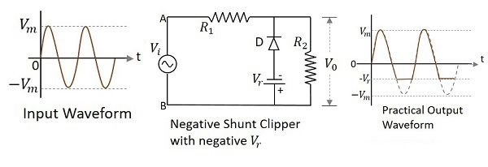

During the positive cycle of the input the diode gets reverse biased and behaves as an open switch. So whole of the input voltage, appears at the output VoVo. During the negative half cycle, the diode gets forward biased. The negative voltage up to the reference voltage, gets at the output and the remaining signal gets clipped off.

18.Define clamper. Explain the working of a positive clamper with waveform

A clamper is an electronic circuit that fixes either the positive or the negative peak excursions of a signal to a defined value by shifting its DC value. The clamper does not restrict the peak-to-peak excursion of the signal, it moves the whole signal up or down so as to place the peaks at the reference level.

## **Positive Clamper Circuit**

A Clamping circuit restores the DC level. When a negative peak of the signal is raised above to the zero level, then the signal is said to be **positively clamped**.

A Positive Clamper circuit is one that consists of a diode, a resistor and a capacitor and that shifts the output signal to the positive portion of the input signal. The figure below explains the construction of a positive clamper circuit.

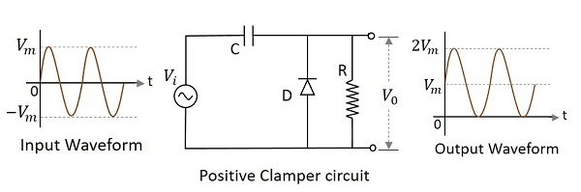

Initially when the input is given, the capacitor is not yet charged and the diode is reverse biased. The output is not considered at this point of time. During the negative half cycle, at the peak value, the capacitor gets charged with negative on one plate and positive on the other. The capacitor is now charged to its peak value VmVm. The diode is forward biased and conducts heavily.

During the next positive half cycle, the capacitor is charged to positive Vm while the diode gets reverse biased and gets open circuited. The output of the circuit at this moment will be

V0=Vi+VmV0=Vi+Vm

Hence the signal is positively clamped as shown in the above figure. The output signal changes according to the changes in the input, but shifts the level according to the charge on the capacitor, as it adds the input voltage.

## **Positive Clamper with Positive Vr**

A Positive clamper circuit if biased with some positive reference voltage, that voltage will be added to the output to raise the clamped level. Using this, the circuit of the positive clamper with positive reference voltage is constructed as below.

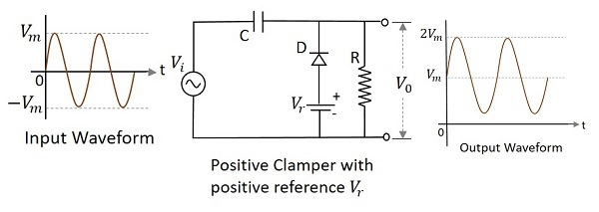

During the positive half cycle, the reference voltage is applied through the diode at the output and as the input voltage increases, the cathode voltage of the diode increase with respect to the anode voltage and hence it stops conducting. During the negative half cycle, the diode gets forward biased and starts conducting. The voltage across the capacitor and the reference voltage together maintain the output voltage level.

## **Positive Clamper with Negative**Vr**Vr**

A Positive clamper circuit if biased with some negative reference voltage, that voltage will be added to the output to raise the clamped level. Using this, the circuit of the positive clamper with positive reference voltage is constructed as below.

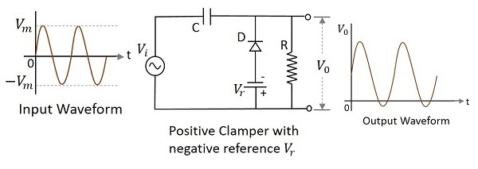

During the positive half cycle, the voltage across the capacitor and the reference voltage together maintain the output voltage level. During the negative half-cycle, the diode conducts when the cathode voltage gets less than the anode voltage. These changes make the output voltage as shown in the above figure.

19. Compare RC oscillators with LC oscillators.

The major difference between the LC and RC oscillator is that **the frequency-determining device in the RC oscillator is not a tank circuit**. Remember, the LC oscillator can operate with class A or C biasing because of the oscillator action of the resonant tank.

20. Explain the working of wean-bridge oscillator with neat diagram.

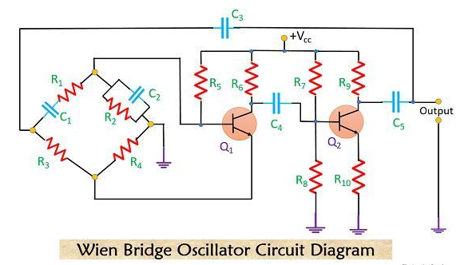

## **Working of Wien bridge oscillator**

Firstly, refer to the above-given [circuit diagram](https://electronicscoach.com/wien-bridge-oscillator.html#circuitdiagram). The oscillations are set in the circuit by an arbitrary change in the base current of transistor Q1 that can be due to noise or any other type of variation in dc supply. The collector circuit of Q1 amplifies the variation of the base current but with 180⁰ phase shift. This amplified output is then fed to the base of transistor Q2 through an intermediate capacitor C2.

Now, Q2 again amplifies the signal and an amplified and twice phase reversed signal is obtained at the output of transistor Q2. Thus the output will in phase with the input voltage.

A part of the output of Q2 is again fed to the input of the bridge circuit. A part of the forwardly biased signal is supplied across R2 which produces positive feedback or we can say regenerative effect and the part which is applied to R4 produces negative feedback or degenerative effect.

To have **sustained oscillations**, the effect of regeneration is made somewhat more than that of degeneration at the rated frequency.

The two capacitors C1 and C2 that we have used in the bridge circuit are**variable air gang capacitors**. We can simply achieve constant frequency by varying C1 and C2 simultaneously.

The output waveform of the Wien bridge oscillator is shown below-

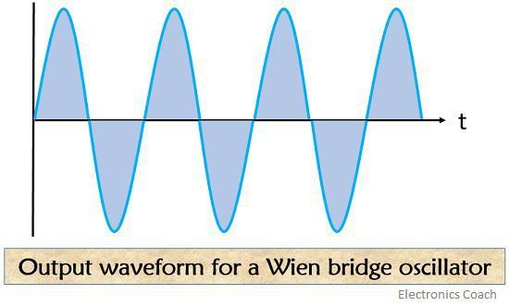

21. Discuss the role of tank circuit in oscillator circuit.

A tank or oscillatory circuit is a parallel form of inductor and capacitor elements which produces the electrical oscillations of any desired frequency. Both these elements are **capable of storing energy**. Whenever the potential difference exists across a capacitor plates, it stores energy in its electric field.19-Aug-2015

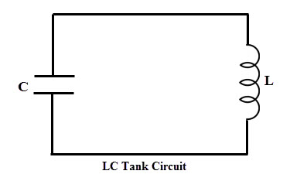

22. Draw& explain RC phase shift oscillator. .

**RC phase-shift oscillators** use resistor-capacitor (RC) network (Figure 1) to provide the phase-shift required by the feedback signal. They have excellent frequency stability and can yield a pure sine wave for a wide range of loads.  
  
Ideally a simple RC network is expected to have an output which leads the input by 90o.

However, in reality, the phase-difference will be less than this as the [capacitor](https://www.electrical4u.com/working-principle-of-a-capacitor/) used in the circuit cannot be ideal. Mathematically the phase angle of the RC network is expressed as  
  
Where, XC = 1/(2πfC) is the reactance of the capacitor C and R is the [resistor](https://www.electrical4u.com/what-is-resistor/). In [oscillators](https://www.electrical4u.com/what-is-an-oscillator/), these kind of RC phase-shift networks, each offering a definite phase-shift can be cascaded so as to satisfy the phase-shift condition led by the Barkhausen Criterion.

One such example is the case in which **RC phase-shift oscillator** is formed by cascading three RC phase-shift networks, each offering a phase-shift of 60o, as shown by Figure 2.

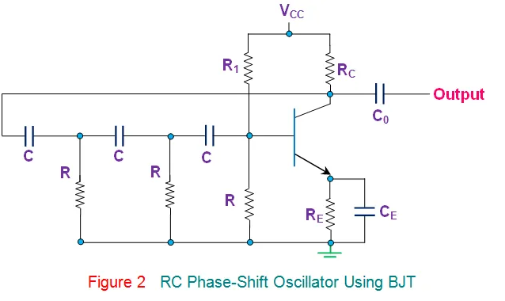  
  
Here the collector resistor RC limits the collector [current](https://www.electrical4u.com/electric-current-and-theory-of-electricity/) of the [transistor](https://www.electrical4u.com/bipolar-junction-transistor-or-bjt-n-p-n-or-p-n-p-transistor/), resistors R1 and R (nearest to the transistor) form the [voltage divider](https://www.electrical4u.com/voltage-divider/) network while the emitter resistor RE improves the stability. Next, the [capacitors](https://www.electrical4u.com/working-principle-of-a-capacitor/) CE and Co are the emitter by-pass capacitor and the output DC decoupling capacitor, respectively. Further, the circuit also shows three RC networks employed in the feedback path.

This arrangement causes the output waveform to shift by 180o during its course of travel from output terminal to the base of the transistor. Next, this signal will be shifted again by 180o by the transistor in the circuit due to the fact that the phase-difference between the input and the output will be 180o in the case of common emitter configuration. This makes the net phase-difference to be 360o, satisfying the phase-difference condition.  
One more way of satisfying the phase-difference condition is to use four RC networks, each offering a phase-shift of 45o. Hence it can be concluded that the **RC phase-shift oscillators** can be designed in many ways as the number of RC networks in them is not fixed. However it is to be noted that, although an increase in the number of stages increases the frequency stability of the circuit, it also adversely affects the output frequency of the oscillator due to the loading effect.  
The generalized expression for the frequency of oscillations produced by a **RC phase-shift oscillator** is given by  
  
Where, N is the number of RC stages formed by the [resistors](https://www.electrical4u.com/types-of-resistor/) R and the capacitors C.  
Further, as is the case for most type of oscillators, even the RC phase-shift oscillators can be designed using an OpAmp as its part of the amplifier section (Figure 3). Nevertheless, the mode of working remains the same while it is to be noted that, here, the required phase-shift of 360o is offered collectively by the RC phase-shift networks and the [Op-Amp](https://www.electrical4u.com/op-amp-working-principle-of-op-amp/) working in inverted configuration.

23. Explain the working of collpitts oscillator.

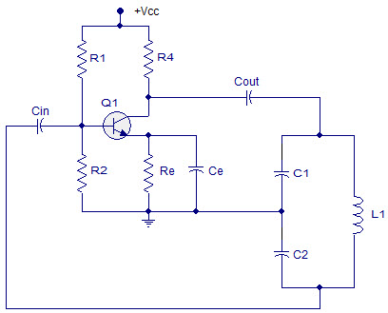

### Colpitts Oscillator Working

Whenever power supply is switched on, the capacitors C1 and C2 shown in the above circuit start charging and after the capacitors get fully charged, the capacitors starts discharging through the inductor L1 in the circuit causing damped harmonic oscillations in the tank circuit.

Thus, an AC voltage is produced across C1 & C2 by the oscillatory current in the tank circuit. While these capacitors get fully discharged, the electrostatic energy stored in the capacitors get transferred in the form of magnetic flux to the inductor and thus inductor gets charged.

Similarly, when the inductor starts discharging, the capacitors start charging again and this process of energy charging and discharging capacitors and inductor continues causing the generation of oscillations and the frequency of these oscillations can be determined by using the resonant frequency of the tank circuit consisting of inductor and capacitors. This tank circuit is considered as the energy reservoir or energy storage. This is because of frequent energy charging and discharging of the inductor, capacitors that part of LC network forming the tank circuit.

The continuous undamped oscillations can be obtained from the Barkhausen criterion. For sustained oscillations, the total phase shift must be 3600 or 00. In the above circuit as two capacitors C1 & C2 are center tapped and grounded, the voltage across capacitor C2 (feedback voltage) is 1800 with the voltage across capacitor C1 (output voltage). The common emitter transistor produces 1800 phase shift between the input and output voltage. Thus, from the Barkhausen criterion we can get undamped continuous oscillations.  
The resonant frequency is given by

**ƒr=1/(2П√(L1\*C))**

Where ƒr is the resonant frequency

C is the equivalent capacitance of series combination of C1 and C2 of the tank circuit

It is given as

**C=(C1\*C2)/((C1+C2))**

L1 represents the self inductance of the coil.

24. What do you understand by multistage transistor amplifier?

In practical applications, the output of a single state amplifier is usually insufficient, though it is a voltage or power amplifier. Hence they are replaced by **Multi-stage transistor amplifiers**.

In Multi-stage amplifiers, the output of first stage is coupled to the input of next stage using a coupling device. These coupling devices can usually be a capacitor or a transformer. This process of joining two amplifier stages using a coupling device can be called as **Cascading**.

The following figure shows a two-stage amplifier connected in cascade.

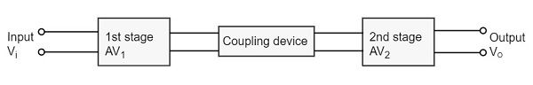

The overall gain is the product of voltage gain of individual stages.

AV=AV1×AV2=V2V1×V0V2=V0V1AV=AV1×AV2=V2V1×V0V2=V0V1

Where AV = Overall gain, AV1 = Voltage gain of 1st stage, and AV2 = Voltage gain of 2nd stage.

If there are **n** number of stages, the product of voltage gains of those **n** stages will be the overall gain of that multistage amplifier circuit.

25. Draw the block diagram of concept of feedback.

A feedback system is the one which utilizes presently achieved output of the system for causing variation in the applied input signal in order to get the required output. More simply, we can say that the presence of a feedback system allows getting the desired output with continuous comparison from the reference input of the system.

Generally, these systems are used to provide more corrective response, by comparing the achieved output with the applied input.

By the use of feedback in a control system, the system shows less sensitivity to the unwanted internal and external disturbances.

## **Block Diagram of Feedback System**

The figure here shows the block diagram of the control system with feedback:

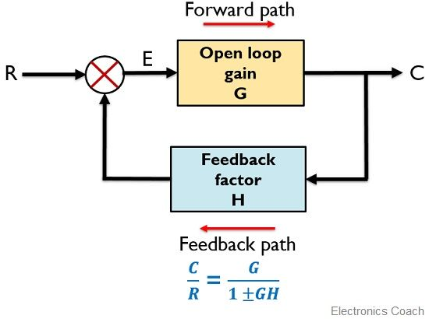

The major concerning factors of a feedback system include sensing, controlling and actuating the process inside the system. More specifically, the reasons for implementing feedback in any electronic circuit are as follows:

* Feedback controls the gain as well as the response of the system.
* The use of feedback introduces the independence of the system’s characteristics with the change in operating conditions like applied voltage and variable temperature.
* The non-linearity of the components present in the system leads to cause a great reduction in signal distortion.

26. Draw the block diagram of sampling network.

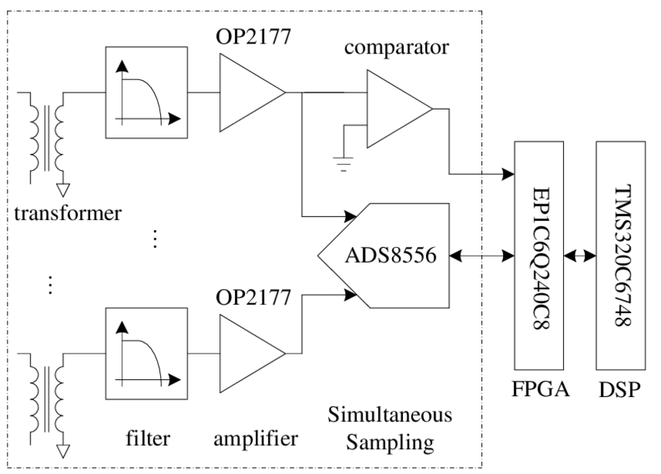

27. Explain why series voltage feedback connection is mostly used?

Because the output current, **Iout of the series connection is fed back as a voltage**, this increases both the input and output impedances of the system. ... Then the “series-series feedback configuration” functions as transconductance type amplifier system as the input signal is a voltage and the output signal is a current.

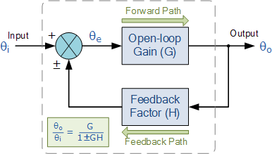

28. Explain the effect of negative feedback on gain. Explain the effect of negative feedback on input impedance.

The effect of negative (or degenerative) feedback is to “reduce” the gain. ... Because negative feedback **produces stable circuit responses**, improves stability and increases the operating bandwidth of a given system, the majority of all control and feedback systems is degenerative reducing the effects of the gain.



Negative feedback **reduces gain of the amplifier**. It also reduce distortion, noise and instability. This feedback increases bandwidth and improves input and output impedances. Due to these advantages, the negative feedback is frequently used in amplifiers.

29. Explain the effect of negative feedback on bandwidth.

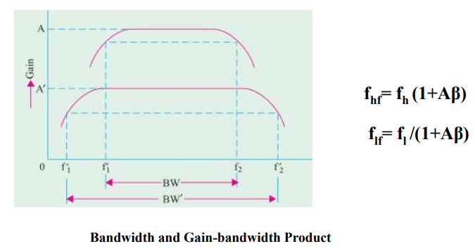

Each of higher and lower cut-off frequencies will improve by a factor of (1+Aβ). However, gain-bandwidth product remains constant. f hf= f h (1+Aβ) f lf = f l /(1+Aβ) An important piece of information that can be obtained from a frequency response curve is the bandwidth of the amplifier. This refers to the ‘band’ of frequencies for which the amplifier has a useful gain. Outside this useful band, the gain of the amplifier is considered to be insufficient compared with the gain at the centre of the bandwidth. The bandwidth specified for the voltage amplifiers is the range of frequencies for which the amplifiers gain is greater than 0.707 of the maximum gain Alternatively, decibels are used to indicate gain, the ratio of output to input voltage. The useful bandwidth would be described as extending to those frequencies at which the gain is -3db down compared to the gain at the mid-band frequency.

30. Explain series voltage feedback.

## **Voltage-Series Feedback**

In the voltage series feedback circuit, a fraction of the output voltage is applied in series with the input voltage through the feedback circuit. This is also known as **shunt-driven series-fed** feedback, i.e., a parallel-series circuit.

The following figure shows the block diagram of voltage series feedback, by which it is evident that the feedback circuit is placed in shunt with the output but in series with the input.

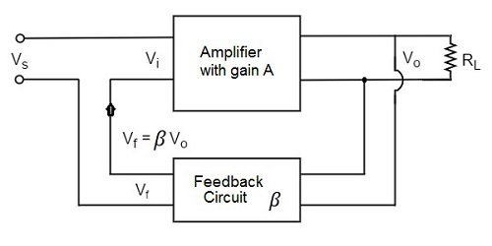

As the feedback circuit is connected in shunt with the output, the output impedance is decreased and due to the series connection with the input, the input impedance is increased.

31. Explain series current feedback.

Current series feedback amplifier is also called as series fed amplifier or transconductance amplifier. In this circuit, current sampling and series mixers are used. When the part of the output current is sampled and given to the feedback circuit, where the fraction of current is converted into a proportional voltage and then given as input signal. By this technique, the input resistance and bandwidth increase but the output gain decrease.

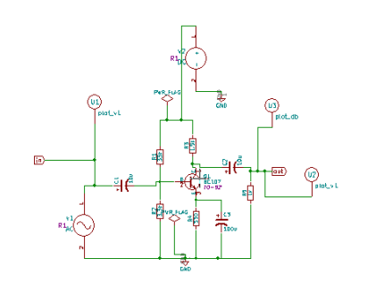

32. Explain shunt voltage feedback.

## **Voltage-Shunt Feedback**

In the voltage shunt feedback circuit, a fraction of the output voltage is applied in parallel with the input voltage through the feedback network. This is also known as **shunt-driven shunt-fed** feedback i.e., a parallel-parallel proto type.

The below figure shows the block diagram of voltage shunt feedback, by which it is evident that the feedback circuit is placed in shunt with the output and also with the input.

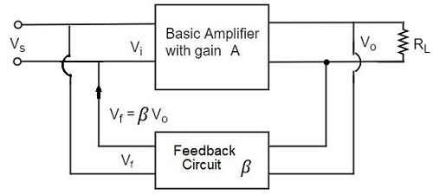

As the feedback circuit is connected in shunt with the output and the input as well, both the output impedance and the input impedance are decreased.

33. Explain shunt current feedback.

## **Current-Shunt Feedback**

In the current shunt feedback circuit, a fraction of the output voltage is applied in series with the input voltage through the feedback circuit. This is also known as **series-driven shunt-fed** feedback i.e., a series-parallel circuit.

The below figure shows the block diagram of current shunt feedback, by which it is evident that the feedback circuit is placed in series with the output but in parallel with the input.

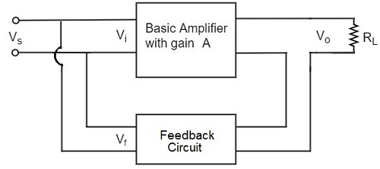

As the feedback circuit is connected in series with the output, the output impedance is increased and due to the parallel connection with the input, the input impedance is decreased.

Let us now tabulate the amplifier characteristics that get affected by different types of negative feedbacks.

34. Explain how negative feedback in an amplifier helps in reducing the distortion.

Using negative feedback to control the gain of the amplifier stages can also reduce amplitude distortion by **ensuring that a signal level is not reached where the output waveform of one stage may drive a following stage into its saturation and/or cut off regions**.

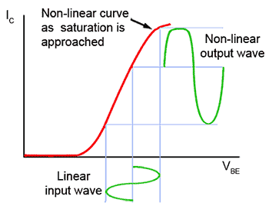

35. Explain how negative feedback in an amplifier helps in stabilizing the gain.

**1. Stabilizes Amplifier Gain**

The negative feedback stabilizes the gain of the amplifier by reducing the dependence of amplifier gain on various transistor parameters or variation in the supply voltage.

***Gvf = Gv / (1 + β . Gv)***

*Here****Gvf****= resultant amplifier gain with negative feedback*

***Gv****= amplifier gain without feedback*

*and****β****is the feedback fraction or feedback ratio*

The above equation clearly shows that the resultant amplifier gain with negative feedback depends mainly on ***feedback fraction or feedback ratio***.

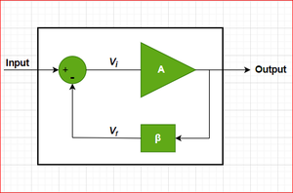

36. Explain how negative feedback in an amplifier helps in increasing the input impedance.

[[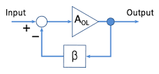](https://www.google.com/search?q=What+happens+to+input+impedance+of+an+amplifier+when+negative+feedback+is+applied?&sxsrf=AOaemvIXidE_Ek5Xi3GCkptrnPLeCI-JeQ:1636908563918&tbm=isch&source=iu&ictx=1&fir=a_r7H53mbW1hbM,0xjfoHKzYk0dRM,_&vet=1&usg=AI4_-kTDXcunD88naEgRyi4IdkjLQmyH4A&sa=X&ved=2ahUKEwjHoO3Lp5j0AhVt7nMBHVhkAoEQ9QF6BAgUEAE#imgrc=a_r7H53mbW1hbM)](https://www.google.com/search?q=What+happens+to+input+impedance+of+an+amplifier+when+negative+feedback+is+applied?&sxsrf=AOaemvIXidE_Ek5Xi3GCkptrnPLeCI-JeQ:1636908563918&tbm=isch&source=iu&ictx=1&fir=a_r7H53mbW1hbM%252C0xjfoHKzYk0dRM%252C_&vet=1&usg=AI4_-kTDXcunD88naEgRyi4IdkjLQmyH4A&sa=X&ved=2ahUKEwjHoO3Lp5j0AhVt7nMBHVhkAoEQ9QF6BAgUEAE" \l "imgrc=a_r7H53mbW1hbM)

an amplifier with gain AOL, a feedback network β, which senses the output signal and possibly transforms it in some way (for example by attenuating **or** filtering it), a summing circuit that acts as a subtractor (the circle in the figure), which combines the input and the transformed output.

37. Explain how negative feedback in an amplifier helps in reducing the output impedance.

In negative feedback, the feedback energy (voltage or current), is out of phase with the input signal and thus opposes it. Negative feedback **reduces gain of the amplifier**. It also reduce distortion, noise and instability. This feedback increases bandwidth and improves input and output impedances.

38. What do you understand by wave shaping circuits?

A wave shaping circuit is the one which can be used to change the shape of a waveform from alternating current or direct current.

For example, a clipper circuit is used to prevent the waveform voltage from exceeding the predetermined voltage without affecting the remaining part of the waveform. This is nothing but waveshaping.

A clamper circuit fixes either the positive or the negative peak excursions of a signal to a defined value by shifting its DC value.

39. Which elements are used in linear and non-linear wave shaping circuits?

Linear elements such as resistors, capacitors and inductors are employed to shape a signal in this linear wave shaping.

Along with resistors, the non-linear elements like **diodes** are used in nonlinear wave shaping circuits to get required altered outputs.

40. Why there is need of wave shaping circuits?

**To generate one wave from the other**. • To limit the voltage level of the waveform to some preset value and suppressing all other voltage levels in excess of the preset level.

41. What do you mean by differentiator circuits?

A **differentiator** is an electronic circuit that produces an output equal to the first derivative of its input. This section discusses about the op-amp based differentiator in detail.

An op-amp based differentiator produces an output, which is equal to the differential of input voltage that is applied to its inverting terminal. The **circuit diagram** of an op-amp based differentiator is shown in the following figure −

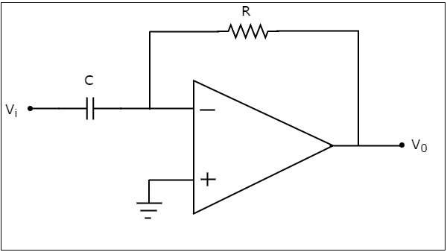

In the above circuit, the non-inverting input terminal of the op-amp is connected to ground. That means zero volts is applied to its non-inverting input terminal.

According to the **virtual short concept**, the voltage at the inverting input terminal of opamp will be equal to the voltage present at its non-inverting input terminal. So, the voltage at the inverting input terminal of op-amp will be zero volts.

The nodal equation at the inverting input terminal's node is −

Cd(0−Vi)dt+0−V0R=0Cd(0−Vi)dt+0−V0R=0

=>−CdVidt=V0R=>−CdVidt=V0R

=>V0=−RCdVidt=>V0=−RCdVidt

If RC=1secRC=1sec, then the output voltage V0V0 will be −

V0=−dVidtV0=−dVidt

Thus, the op-amp based differentiator circuit shown above will produce an output, which is the differential of input voltage ViVi, when the magnitudes of impedances of resistor and capacitor are reciprocal to each other.

Note that the output voltage V0V0 is having a **negative sign**, which indicates that there exists a 1800 phase difference between the input and the output.

42.What do you mean by integrator circuits?

An **integrator** is an electronic circuit that produces an output that is the integration of the applied input. This section discusses about the op-amp based integrator.

An op-amp based integrator produces an output, which is an integral of the input voltage applied to its inverting terminal. The **circuit diagram** of an op-amp based integrator is shown in the following figure −

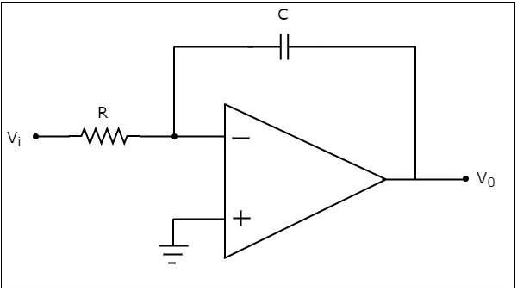

In the circuit shown above, the non-inverting input terminal of the op-amp is connected to ground. That means zero volts is applied to its non-inverting input terminal.

According to **virtual short concept**, the voltage at the inverting input terminal of op-amp will be equal to the voltage present at its non-inverting input terminal. So, the voltage at the inverting input terminal of op-amp will be zero volts.

The **nodal equation** at the inverting input terminal is −

0−ViR+Cd(0−V0)dt=00−ViR+Cd(0−V0)dt=0

=>−ViR=CdV0dt=>−ViR=CdV0dt

=>dV0dt=−ViRC=>dV0dt=−ViRC

=>dV0=(−ViRC)dt=>dV0=(−ViRC)dt

Integrating both sides of the equation shown above, we get −

∫dV0=∫(−ViRC)dt∫dV0=∫(−ViRC)dt

=>V0=−1RC∫Vtdt=>V0=−1RC∫Vtdt

If RC=1secRC=1sec, then the output voltage, V0V0 will be −

V0=−∫VidtV0=−∫Vidt

So, the op-amp based integrator circuit discussed above will produce an output, which is the integral of input voltage ViVi, when the magnitude of impedances of resistor and capacitor are reciprocal to each other.

43.What do you mean by clipping circuits?

# **Clipper Circuits**

**Definition**: **Clipper circuits** are the circuits that **clip off** or **removes** a **portion of an input signal**, without causing any distortion to the remaining part of the waveform. These are also known as clippers, clipping circuits, limiters, slicers etc.

Clippers are basically **wave shaping circuits** that control the shape of an output waveform. It consists of linear and non-linear elements but does not contain energy storing elements.

The basic operation of a diode clipping circuits is such that, in forward biased condition, the diode allows current to pass through it, clamping the voltage. But in reverse biased condition, no any current flows through the diode, and thus voltage remains unaffected across its terminals.

**Clipper circuits** are basically termed as **protection devices**. As electronic devices are voltage sensitive and voltage of large amplitude can permanently destroy the device. So, in order to protect the device clipper circuits are used.

Usually, clippers employ [resistor](https://electronicscoach.com/resistor.html)**–**[diode](https://electronicscoach.com/diode.html) combination in its circuitry.

44.What do you mean by clamping circuits?

A Clamper Circuit is a circuit that adds a DC level to an AC signal. Actually, the positive and negative peaks of the signals can be placed at desired levels using the clamping circuits. As the DC level gets shifted, a clamper circuit is called as a **Level Shifter**.

Clamper circuits consist of energy storage elements like capacitors. A simple clamper circuit comprises of a capacitor, a diode, a resistor and a dc battery if required.

## **Clamper Circuit**

A Clamper circuit can be defined as the circuit that consists of a diode, a resistor and a capacitor that shifts the waveform to a desired DC level without changing the actual appearance of the applied signal.

In order to maintain the time period of the wave form, the **tau** must be greater than, half the time period dischargingtimeofthecapacitorshouldbeslow.dischargingtimeofthecapacitorshouldbeslow.

τ=Rcτ=Rc

Where

* R is the resistance of the resistor employed
* C is the capacitance of the capacitor used

The time constant of charge and discharge of the capacitor determines the output of a clamper circuit.

* In a clamper circuit, a vertical shift of upward or downward takes place in the output waveform with respect to the input signal.
* The load resistor and the capacitor affect the waveform. So, the discharging time of the capacitor should be large enough.

The DC component present in the input is rejected when a capacitor coupled network is used asacapacitorblocksdcasacapacitorblocksdc. Hence when **dc** needs to be **restored**, clamping circuit is used.

45.What do you mean by positive clipper circuits?

### Positive Series Clipper

A Clipper circuit in which the diode is connected in series to the input signal and that attenuates the positive portions of the waveform, is termed as **Positive Series Clipper**. The following figure represents the circuit diagram for positive series clipper.

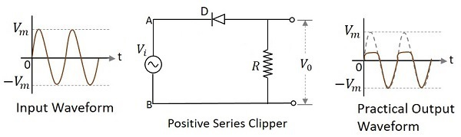

**Positive Cycle of the Input** − When the input voltage is applied, the positive cycle of the input makes the point A in the circuit positive with respect to the point B. This makes the diode reverse biased and hence it behaves like an open switch. Thus the voltage across the load resistor becomes zero as no current flows through it and hence V0V0 will be zero.

**Negative Cycle of the Input** − The negative cycle of the input makes the point A in the circuit negative with respect to the point B. This makes the diode forward biased and hence it conducts like a closed switch. Thus the voltage across the load resistor will be equal to the applied input voltage as it completely appears at the output V0V0.

### Waveforms

In the above figures, if the waveforms are observed, we can understand that only a portion of the positive peak was clipped. This is because of the voltage across V0. But the ideal output was not meant to be so. Let us have a look at the following figures.

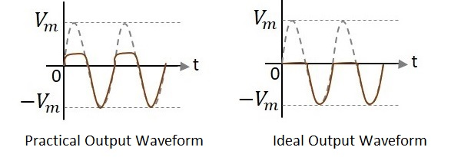

Unlike the ideal output, a bit portion of the positive cycle is present in the practical output due to the diode conduction voltage which is 0.7v. Hence there will be a difference in the practical and ideal output waveforms.

### Positive Series Clipper with positive **Vr**Vr

A Clipper circuit in which the diode is connected in series to the input signal and biased with positive reference voltage VrVr and that attenuates the positive portions of the waveform, is termed as **Positive Series Clipper with positive**VrVr. The following figure represents the circuit diagram for positive series clipper when the reference voltage applied is positive.

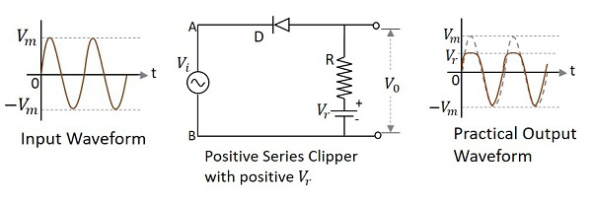

During the positive cycle of the input the diode gets reverse biased and the reference voltage appears at the output. During its negative cycle, the diode gets forward biased and conducts like a closed switch. Hence the output waveform appears as shown in the above figure.

### Positive Series Clipper with negative **Vr**Vr

A Clipper circuit in which the diode is connected in series to the input signal and biased with negative reference voltage VrVr and that attenuates the positive portions of the waveform, is termed as **Positive Series Clipper with negative**VrVr. The following figure represents the circuit diagram for positive series clipper, when the reference voltage applied is negative.

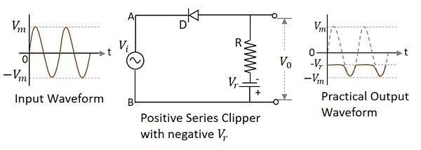

During the positive cycle of the input the diode gets reverse biased and the reference voltage appears at the output. As the reference voltage is negative, the same voltage with constant amplitude is shown. During its negative cycle, the diode gets forward biased and conducts like a closed switch. Hence the input signal that is greater than the reference voltage, appears at the output.

## **Positive Shunt Clipper**

A Clipper circuit in which the diode is connected in shunt to the input signal and that attenuates the positive portions of the waveform, is termed as **Positive Shunt Clipper**. The following figure represents the circuit diagram for positive shunt clipper.

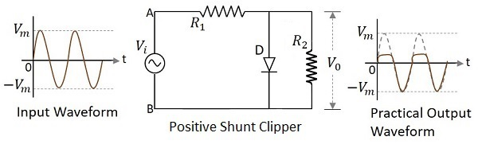

**Positive Cycle of the Input** − When the input voltage is applied, the positive cycle of the input makes the point A in the circuit positive with respect to the point B. This makes the diode forward biased and hence it conducts like a closed switch. Thus the voltage across the load resistor becomes zero as no current flows through it and hence V0V0 will be zero.

**Negative Cycle of the Input** − The negative cycle of the input makes the point A in the circuit negative with respect to the point B. This makes the diode reverse biased and hence it behaves like an open switch. Thus the voltage across the load resistor will be equal to the applied input voltage as it completely appears at the output V0V0.

### Waveforms

In the above figures, if the waveforms are observed, we can understand that only a portion of the positive peak was clipped. This is because of the voltage across V0V0. But the ideal output was not meant to be so. Let us have a look at the following figures.

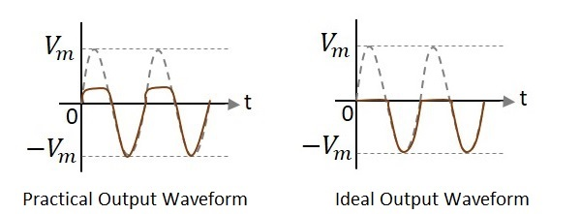

Unlike the ideal output, a bit portion of the positive cycle is present in the practical output due to the diode conduction voltage which is 0.7v. Hence there will be a difference in the practical and ideal output waveforms.

### Positive Shunt Clipper with positive **Vr**Vr

A Clipper circuit in which the diode is connected in shunt to the input signal and biased with positive reference voltage VrVr and that attenuates the positive portions of the waveform, is termed as **Positive Shunt Clipper with positive** VrVr. The following figure represents the circuit diagram for positive shunt clipper when the reference voltage applied is positive.

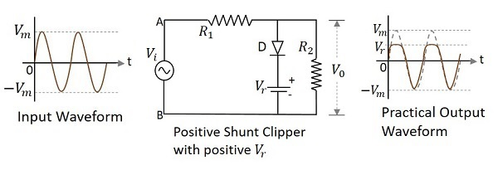

During the positive cycle of the input the diode gets forward biased and nothing but the reference voltage appears at the output. During its negative cycle, the diode gets reverse biased and behaves as an open switch. The whole of the input appears at the output. Hence the output waveform appears as shown in the above figure.

### Positive Shunt Clipper with negative **Vr**Vr

A Clipper circuit in which the diode is connected in shunt to the input signal and biased with negative reference voltage VrVr and that attenuates the positive portions of the waveform, is termed as **Positive Shunt Clipper with negative** VrVr.

The following figure represents the circuit diagram for positive shunt clipper, when the reference voltage applied is negative.

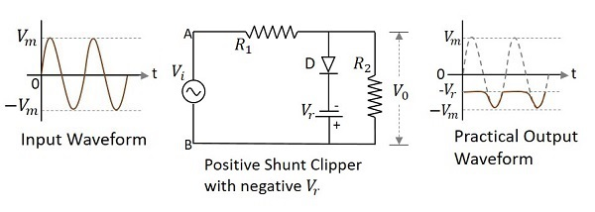

During the positive cycle of the input, the diode gets forward biased and the reference voltage appears at the output. As the reference voltage is negative, the same voltage with constant amplitude is shown. During its negative cycle, the diode gets reverse biased and behaves as an open switch. Hence the input signal that is greater than the reference voltage, appears at the output.

46.What do you mean by negative clipper circuits?

## **Negative Series Clipper**

A Clipper circuit in which the diode is connected in series to the input signal and that attenuates the negative portions of the waveform, is termed as **Negative Series Clipper**. The following figure represents the circuit diagram for negative series clipper.

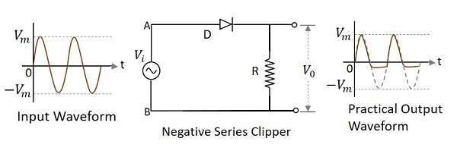

**Positive Cycle of the Input** − When the input voltage is applied, the positive cycle of the input makes the point A in the circuit positive with respect to the point B. This makes the diode forward biased and hence it acts like a closed switch. Thus the input voltage completely appears across the load resistor to produce the output V0V0.

**Negative Cycle of the Input** − The negative cycle of the input makes the point A in the circuit negative with respect to the point B. This makes the diode reverse biased and hence it acts like an open switch. Thus the voltage across the load resistor will be zero making V0V0 zero.

### Waveforms

In the above figures, if the waveforms are observed, we can understand that only a portion of the negative peak was clipped. This is because of the voltage across V0V0. But the ideal output was not meant to be so. Let us have a look at the following figures.

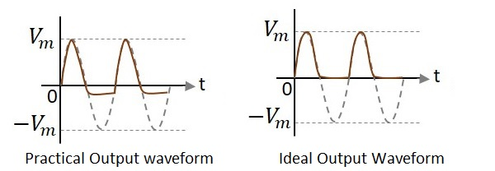

Unlike the ideal output, a bit portion of the negative cycle is present in the practical output due to the diode conduction voltage which is 0.7v. Hence there will be a difference in the practical and ideal output waveforms.

### Negative Series Clipper with positive **Vr**Vr

A Clipper circuit in which the diode is connected in series to the input signal and biased with positive reference voltage VrVr and that attenuates the negative portions of the waveform, is termed as **Negative Series Clipper with positive** VrVr. The following figure represents the circuit diagram for negative series clipper when the reference voltage applied is positive.

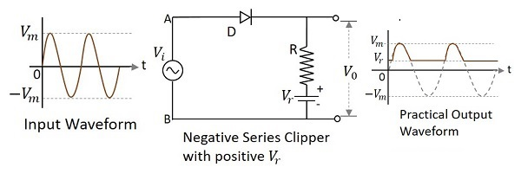

During the positive cycle of the input, the diode starts conducting only when the anode voltage value exceeds the cathode voltage value of the diode. As the cathode voltage equals the reference voltage applied, the output will be as shown.

### Negative Series Clipper with negative **Vr**Vr

A Clipper circuit in which the diode is connected in series to the input signal and biased with negative reference voltage VrVr and that attenuates the negative portions of the waveform, is termed as **Negative Series Clipper with negative** VrVr. The following figure represents the circuit diagram for negative series clipper, when the reference voltage applied is negative.

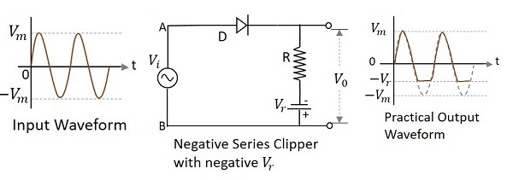

During the positive cycle of the input the diode gets forward biased and the input signal appears at the output. During its negative cycle, the diode gets reverse biased and hence will not conduct. But the negative reference voltage being applied, appears at the output. Hence the negative cycle of the output waveform gets clipped after this reference level.

## **Negative Shunt Clipper**

A Clipper circuit in which the diode is connected in shunt to the input signal and that attenuates the negative portions of the waveform, is termed as Negative Shunt Clipper. The following figure represents the circuit diagram for **negative shunt clipper**.



**Positive Cycle of the Input** − When the input voltage is applied, the positive cycle of the input makes the point A in the circuit positive with respect to the point B. This makes the diode reverse biased and hence it behaves like an open switch. Thus the voltage across the load resistor equals the applied input voltage as it completely appears at the output V0V0

**Negative Cycle of the Input** − The negative cycle of the input makes the point A in the circuit negative with respect to the point B. This makes the diode forward biased and hence it conducts like a closed switch. Thus the voltage across the load resistor becomes zero as no current flows through it.

### Waveforms

In the above figures, if the waveforms are observed, we can understand that just a portion of the negative peak was clipped. This is because of the voltage across V0V0. But the ideal output was not meant to be so. Let us have a look at the following figures.



Unlike the ideal output, a bit portion of the negative cycle is present in the practical output due to the diode conduction voltage which is 0.7v. Hence there will be a difference in the practical and ideal output waveforms.

### Negative Shunt Clipper with positive **Vr**Vr

A Clipper circuit in which the diode is connected in shunt to the input signal and biased with positive reference voltage VrVr and that attenuates the negative portions of the waveform, is termed as **Negative Shunt Clipper with positive**VrVr. The following figure represents the circuit diagram for negative shunt clipper when the reference voltage applied is positive.



During the positive cycle of the input the diode gets reverse biased and behaves as an open switch. So whole of the input voltage, which is greater than the reference voltage applied, appears at the output. The signal below reference voltage level gets clipped off.

During the negative half cycle, as the diode gets forward biased and the loop gets completed, no output is present.

### Negative Shunt Clipper with negative **Vr**Vr

A Clipper circuit in which the diode is connected in shunt to the input signal and biased with negative reference voltage VrVr and that attenuates the negative portions of the waveform, is termed as **Negative Shunt Clipper with negative** VrVr. The following figure represents the circuit diagram for negative shunt clipper, when the reference voltage applied is negative.



During the positive cycle of the input the diode gets reverse biased and behaves as an open switch. So whole of the input voltage, appears at the output VoVo. During the negative half cycle, the diode gets forward biased. The negative voltage up to the reference voltage, gets at the output and the remaining signal gets clipped off.

47.What do you mean by positive clamping circuits?

## **Positive Clamper Circuit**

A Clamping circuit restores the DC level. When a negative peak of the signal is raised above to the zero level, then the signal is said to be **positively clamped**.

A Positive Clamper circuit is one that consists of a diode, a resistor and a capacitor and that shifts the output signal to the positive portion of the input signal. The figure below explains the construction of a positive clamper circuit.



Initially when the input is given, the capacitor is not yet charged and the diode is reverse biased. The output is not considered at this point of time. During the negative half cycle, at the peak value, the capacitor gets charged with negative on one plate and positive on the other. The capacitor is now charged to its peak value VmVm. The diode is forward biased and conducts heavily.

During the next positive half cycle, the capacitor is charged to positive Vm while the diode gets reverse biased and gets open circuited. The output of the circuit at this moment will be

V0=Vi+VmV0=Vi+Vm

Hence the signal is positively clamped as shown in the above figure. The output signal changes according to the changes in the input, but shifts the level according to the charge on the capacitor, as it adds the input voltage.

## **Positive Clamper with Positive Vr**

A Positive clamper circuit if biased with some positive reference voltage, that voltage will be added to the output to raise the clamped level. Using this, the circuit of the positive clamper with positive reference voltage is constructed as below.



During the positive half cycle, the reference voltage is applied through the diode at the output and as the input voltage increases, the cathode voltage of the diode increase with respect to the anode voltage and hence it stops conducting. During the negative half cycle, the diode gets forward biased and starts conducting. The voltage across the capacitor and the reference voltage together maintain the output voltage level.

## **Positive Clamper with Negative**Vr**Vr**

A Positive clamper circuit if biased with some negative reference voltage, that voltage will be added to the output to raise the clamped level. Using this, the circuit of the positive clamper with positive reference voltage is constructed as below.



During the positive half cycle, the voltage across the capacitor and the reference voltage together maintain the output voltage level. During the negative half-cycle, the diode conducts when the cathode voltage gets less than the anode voltage. These changes make the output voltage as shown in the above figure.

## **Negative Clamper**

A Negative Clamper circuit is one that consists of a diode, a resistor and a capacitor and that shifts the output signal to the negative portion of the input signal. The figure below explains the construction of a negative clamper circuit.

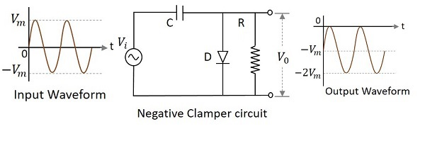

During the positive half cycle, the capacitor gets charged to its peak value vmvm. The diode is forward biased and conducts. During the negative half cycle, the diode gets reverse biased and gets open circuited. The output of the circuit at this moment will be

V0=Vi+VmV0=Vi+Vm

Hence the signal is negatively clamped as shown in the above figure. The output signal changes according to the changes in the input, but shifts the level according to the charge on the capacitor, as it adds the input voltage.

## **Negative clamper with positive Vr**

A Negative clamper circuit if biased with some positive reference voltage, that voltage will be added to the output to raise the clamped level. Using this, the circuit of the negative clamper with positive reference voltage is constructed as below.

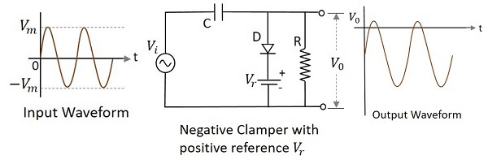

Though the output voltage is negatively clamped, a portion of the output waveform is raised to the positive level, as the applied reference voltage is positive. During the positive half-cycle, the diode conducts, but the output equals the positive reference voltage applied. During the negative half cycle, the diode acts as open circuited and the voltage across the capacitor forms the output.

## **Negative Clamper with Negative Vr**

A Negative clamper circuit if biased with some negative reference voltage, that voltage will be added to the output to raise the clamped level. Using this, the circuit of the negative clamper with negative reference voltage is constructed as below.

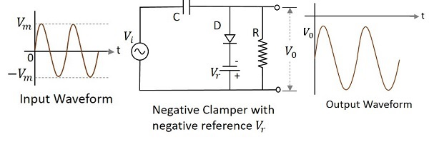

The cathode of the diode is connected with a negative reference voltage, which is less than that of zero and the anode voltage. Hence the diode starts conducting during positive half cycle, before the zero voltage level. During the negative half cycle, the voltage across the capacitor appears at the output. Thus the waveform is clamped towards the negative portion.

48.What do you mean by negative clamping circuits

## **Negative Clamper**

A Negative Clamper circuit is one that consists of a diode, a resistor and a capacitor and that shifts the output signal to the negative portion of the input signal. The figure below explains the construction of a negative clamper circuit.



During the positive half cycle, the capacitor gets charged to its peak value vmvm. The diode is forward biased and conducts. During the negative half cycle, the diode gets reverse biased and gets open circuited. The output of the circuit at this moment will be

V0=Vi+VmV0=Vi+Vm

Hence the signal is negatively clamped as shown in the above figure. The output signal changes according to the changes in the input, but shifts the level according to the charge on the capacitor, as it adds the input voltage.

## **Negative clamper with positive Vr**

A Negative clamper circuit if biased with some positive reference voltage, that voltage will be added to the output to raise the clamped level. Using this, the circuit of the negative clamper with positive reference voltage is constructed as below.



Though the output voltage is negatively clamped, a portion of the output waveform is raised to the positive level, as the applied reference voltage is positive. During the positive half-cycle, the diode conducts, but the output equals the positive reference voltage applied. During the negative half cycle, the diode acts as open circuited and the voltage across the capacitor forms the output.

## **Negative Clamper with Negative Vr**

A Negative clamper circuit if biased with some negative reference voltage, that voltage will be added to the output to raise the clamped level. Using this, the circuit of the negative clamper with negative reference voltage is constructed as below.



The cathode of the diode is connected with a negative reference voltage, which is less than that of zero and the anode voltage. Hence the diode starts conducting during positive half cycle, before the zero voltage level. During the negative half cycle, the voltage across the capacitor appears at the output. Thus the waveform is clamped towards the negative portion.